PRAKTIKUM BASIS DATA

MODUL 5
05_Scripting_Agregate_Function

Oleh:

Haryanto Wifakul Azmi 103122400037

PROGRAM STUDI S1 REKAYASA PERANGKAT LUNAK
DIREKTORAT KAMPUS PURWOKERTO
UNIVERSITAS TELKOM
2026
Jurnal

- Tampilkan nomor teater beserta judul film nya yang memiliki pendapatan total lebih dari 150000 !
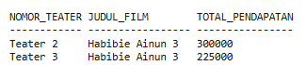
Jawaban:
Query:
SELECT j.ID_THEATER, f.JUDUL, SUM(t2.HARGA) AS TOTAL_PENDAPATAN
FROM TRANSAKSI t
JOIN JADWAL j ON t.ID_JADWAL = j.ID_JADWAL
JOIN FILM f ON j.ID_FILM = f.ID_FILM
JOIN THEATER t2 ON j.ID_THEATER = t2.ID_THEATER
GROUP BY j.ID_THEATER, f.JUDUL
HAVING SUM(t2.HARGA) > 150000;
Output:
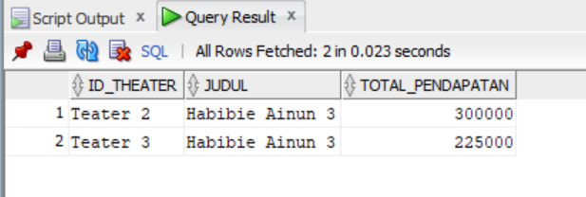
- Tampilkan film yang paling banyak ditonton dan status = pesan !

Jawaban:
Query:
SELECT f.JUDUL, COUNT(*) AS JUMLAH_TONTON
FROM TRANSAKSI t
JOIN JADWAL j ON t.ID_JADWAL = j.ID_JADWAL
JOIN FILM f ON j.ID_FILM = f.ID_FILM
WHERE t.STATUS = 'pesan'
GROUP BY f.JUDUL
HAVING COUNT(*) = (
SELECT MAX(jumlah)
FROM (
SELECT COUNT(*) AS jumlah
FROM TRANSAKSI t2
JOIN JADWAL j2 ON t2.ID_JADWAL = j2.ID_JADWAL
WHERE t2.STATUS = 'pesan'
GROUP BY j2.ID_FILM
)
);
Outpurt:
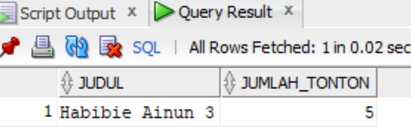
- Tampilkan nomor teater dan rata rata pendapatannya !
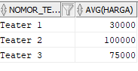
Jawaban:
Query:
SELECT j.ID_THEATER, AVG(t2.HARGA) AS RATA_PENDAPATAN
FROM TRANSAKSI t
JOIN JADWAL j ON t.ID_JADWAL = j.ID_JADWAL
JOIN THEATER t2 ON j.ID_THEATER = t2.ID_THEATER
GROUP BY j.ID_THEATER;
Output:
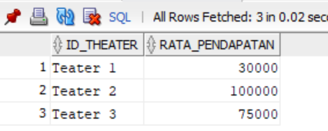
- Tampilkan judul, nomor teater, dan jumlah film yang diputar. Dimana film yang berjudul film ‘Habibie Ainun 3’ !

Jawaban:
Query:
SELECT f.JUDUL, j.ID_THEATER, COUNT(*) AS JUMLAH_PUTAR
FROM JADWAL j
JOIN FILM f ON j.ID_FILM = f.ID_FILM
WHERE f.JUDUL = 'Habibie Ainun 3'
GROUP BY f.JUDUL, j.ID_THEATER;
Output:
